**NAAN MUDHALVAN PROJECT DOCUMENTATION**

**VENKATESH S**

**VIGNESH R**

**THIRUNESAN B**

**NAVEEN KUMAR M**

# STEP 1: GO TO MAIL CHIMP IN YOUR BROWSER

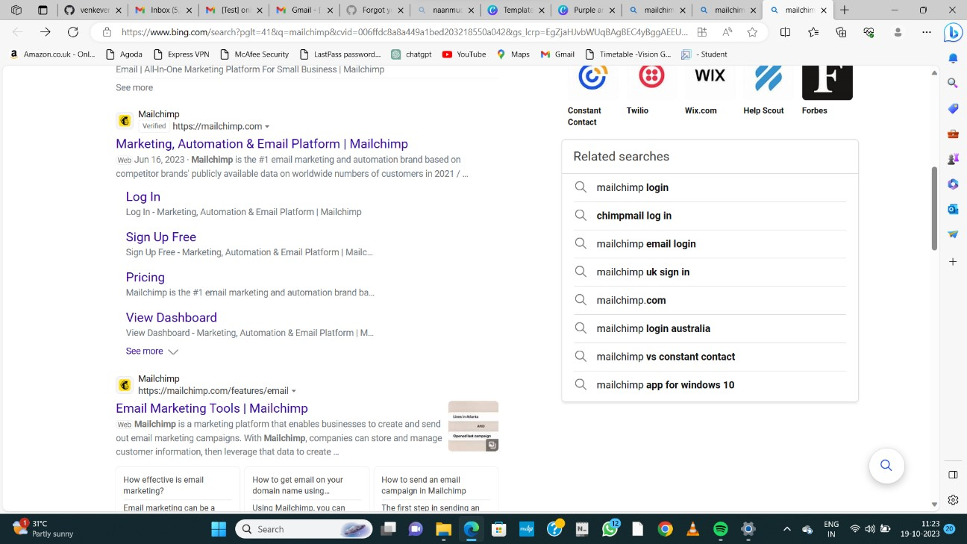

# STEP 2:LOGIN TO YOUR MAIL CHIMP ACCOUNT

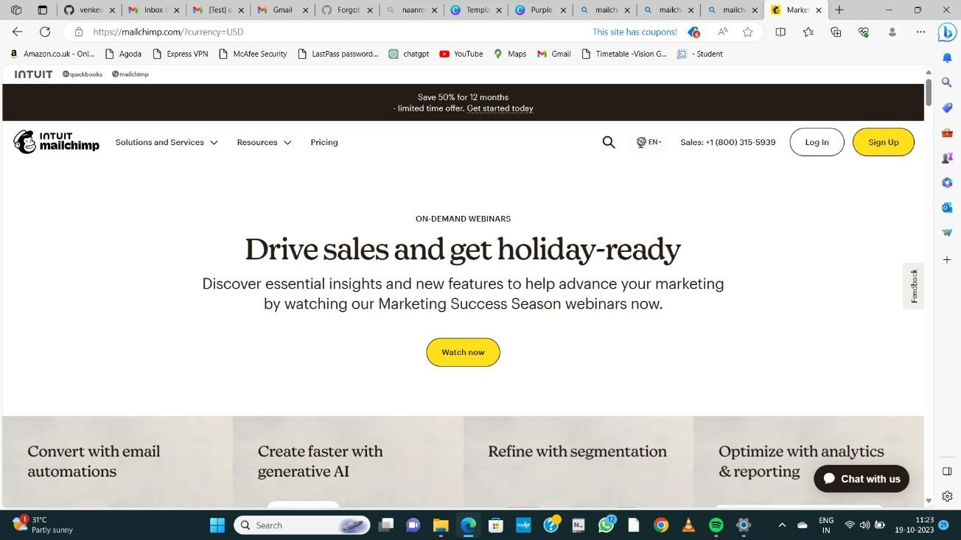

# STEP 3: LOGIN WITH FREE ACCOUNT

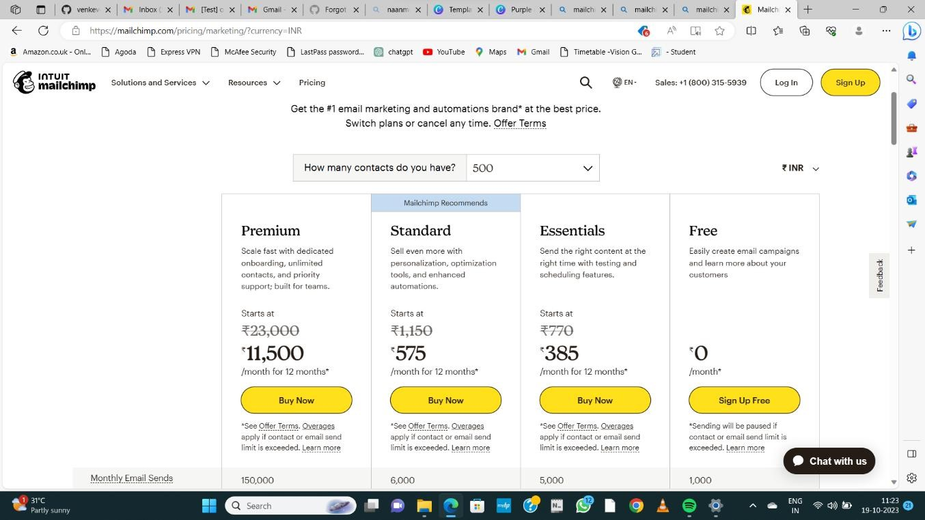

# STEP 4: LOGIN INTO MAILCHIMP

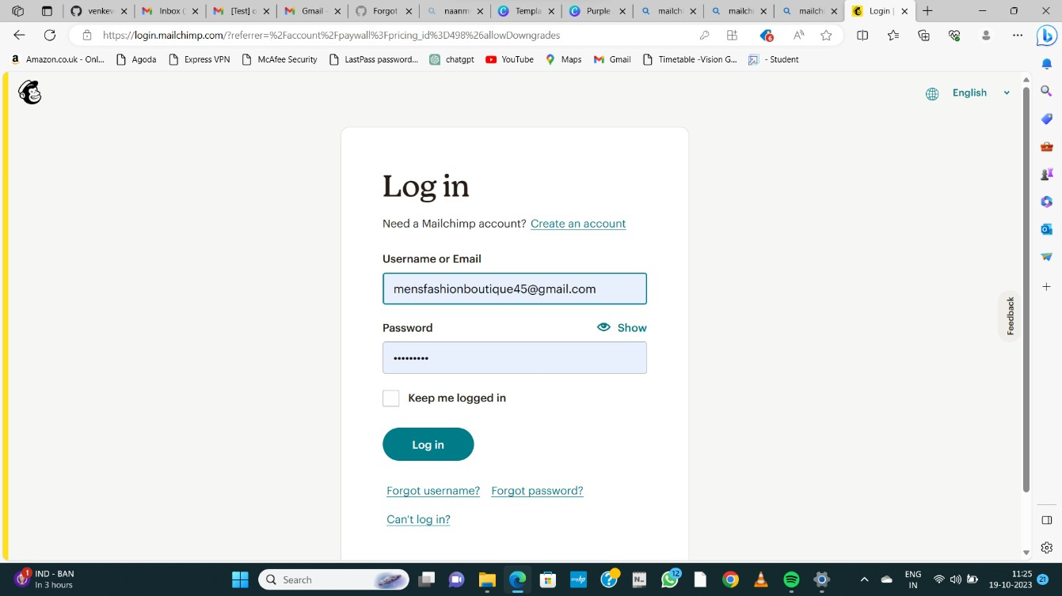

**Step 5: go to create to create a new email newsletter**

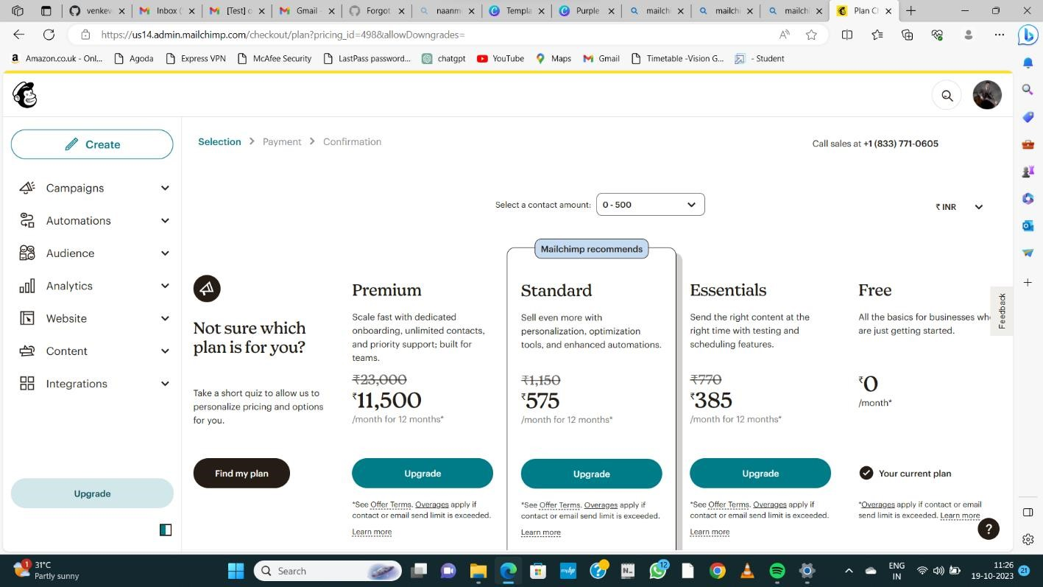

# STEP 6: CLICK DESIGN EMAIL

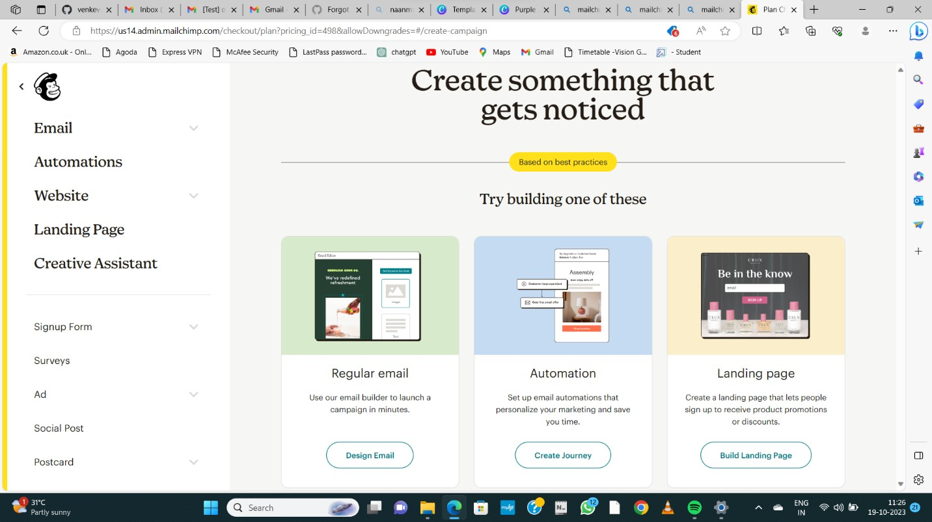

**STEP 7: ADD FROM, TO, SUBJECT AND**

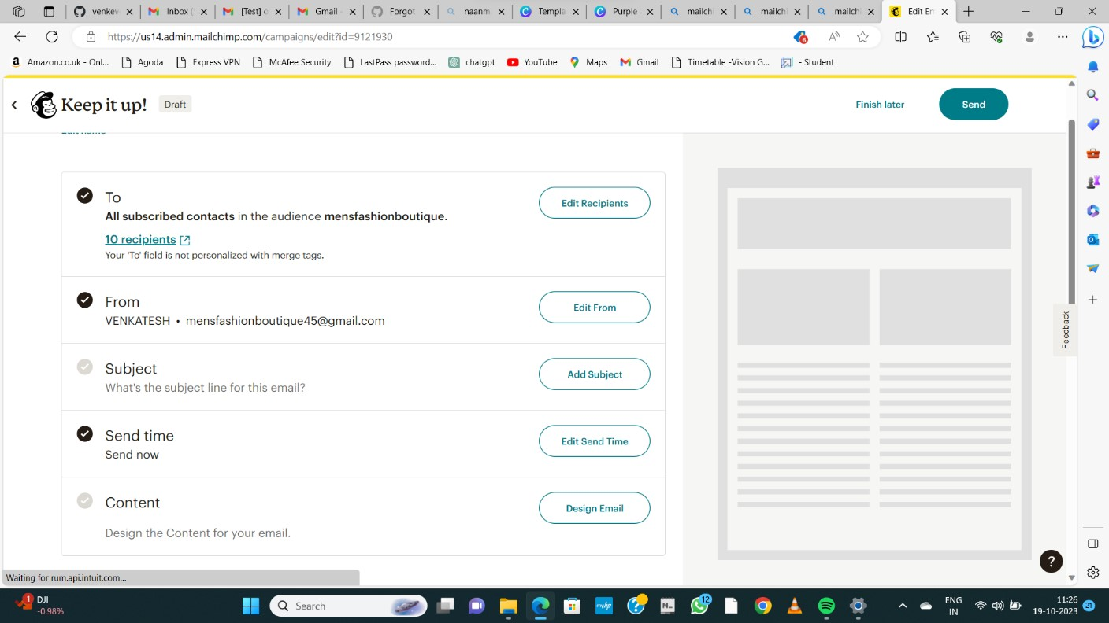

# STEP 8: SELECT ANY 1 DEAFULT TEMPLATE

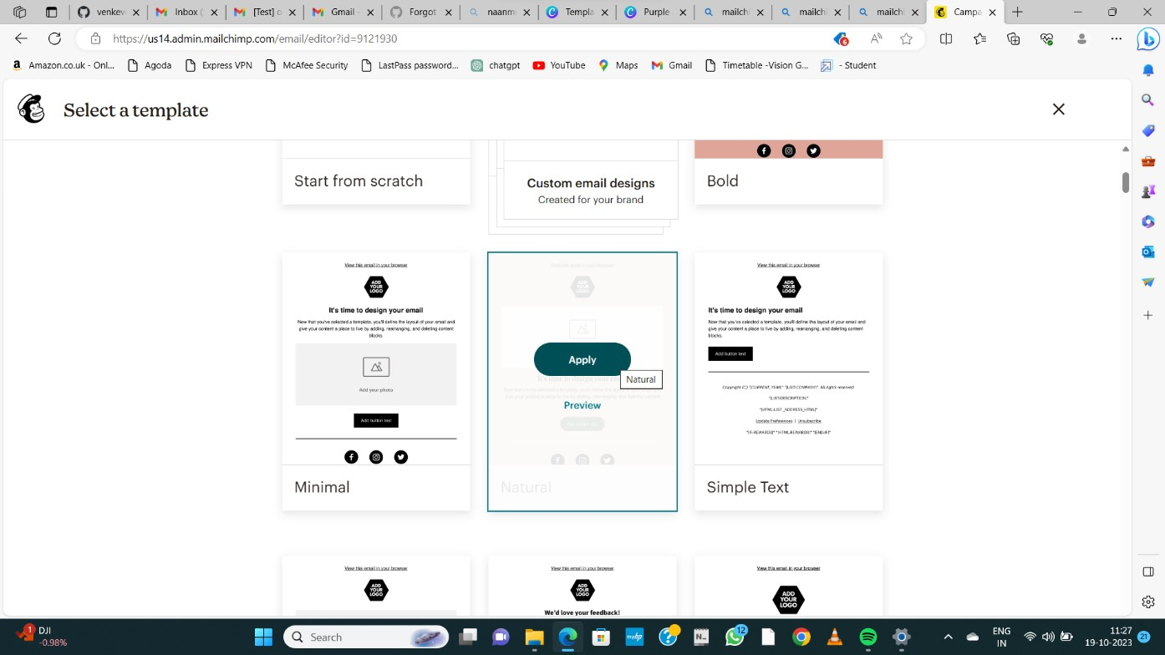

# STEP 9: ADD LOGO AND OTHER CHANGES CLICK SAVE AND EXIT

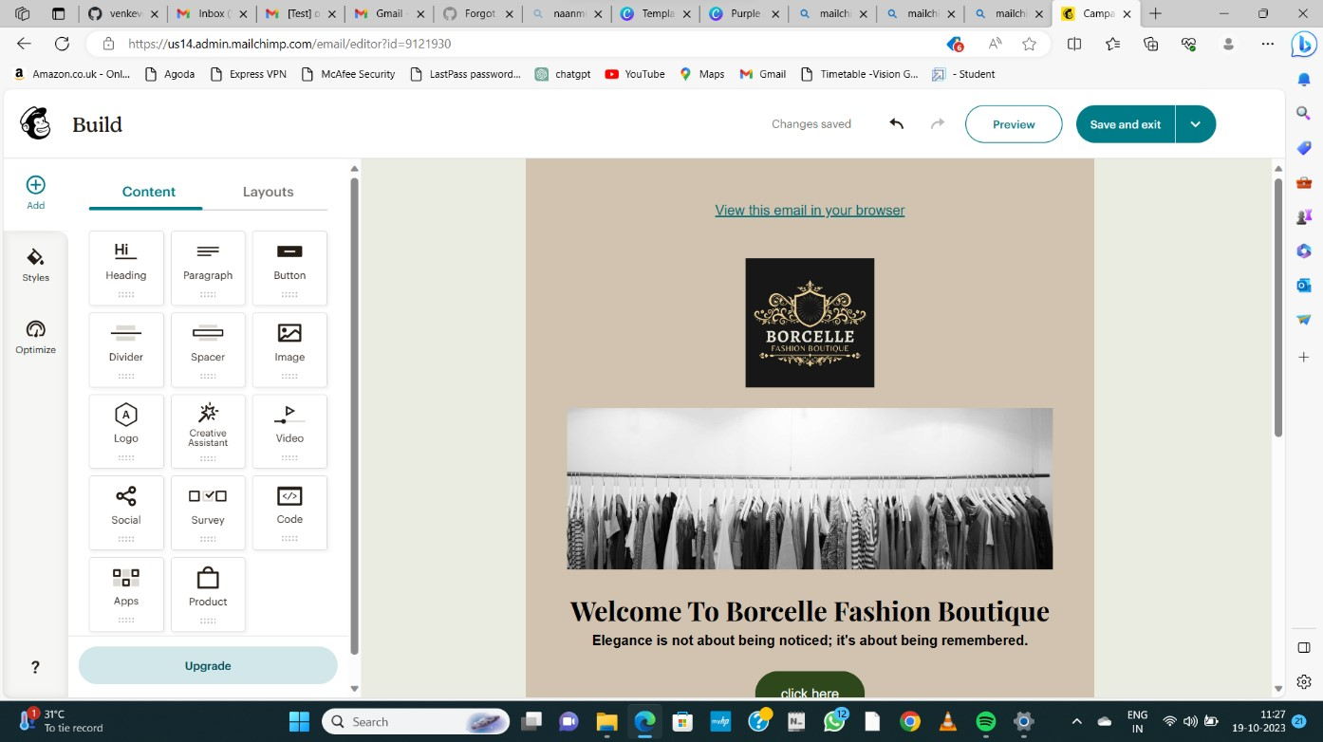

**STEP 10: NOW SEND A TEST MAIL BY GIVING A RECIPIENTS**

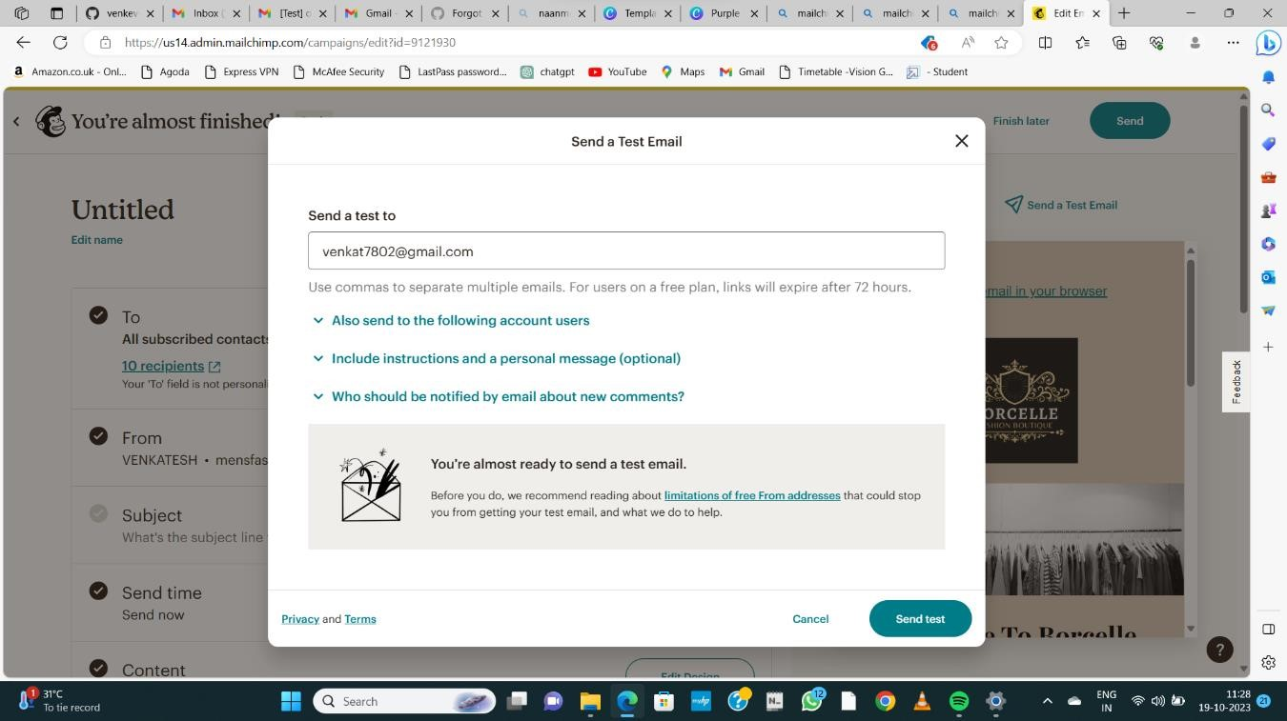

# STEP 11: CONFIRMATION RECEIVED

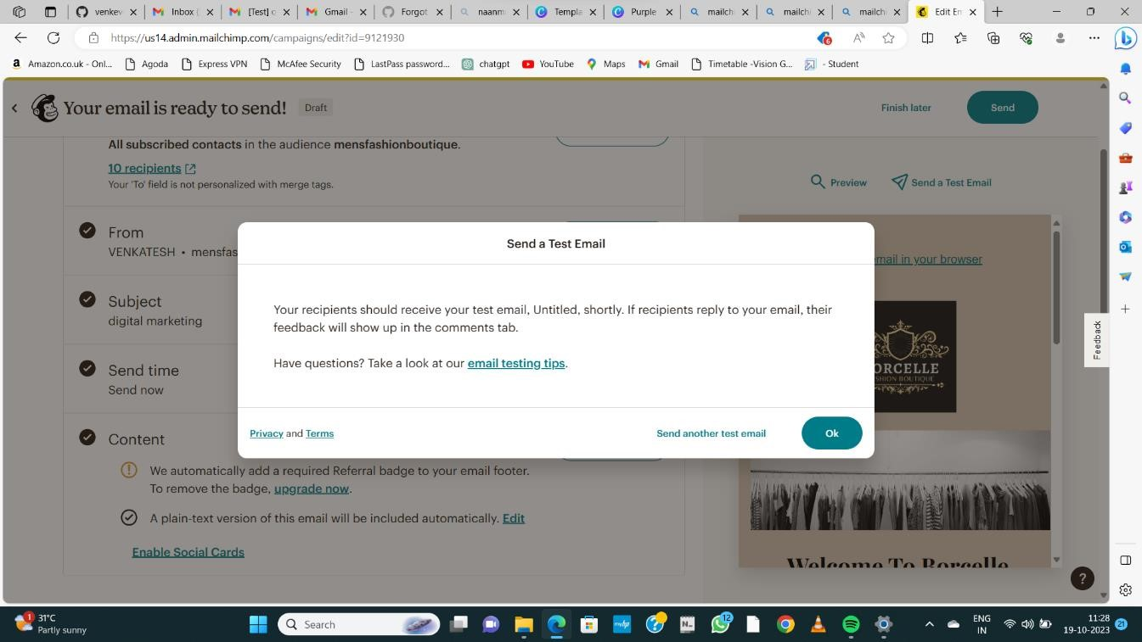

# STEP 12: GO TO GIVEN EMAIL AND DOWNLOAD TEST MAIL

